**Art | Ray Mark Rinaldi**

**Art by Judy Chicago and Dorothea Lange, and their husbands, highlighted in Colorado shows**

Posted: 03/15/2013 12:57:15 PM MDT  
March 16, 2013 11:10 PM GMTUpdated: 03/16/2013 05:10:53 PM MDT

**By Ray Mark Rinaldi**  
*The Denver Post*denverpost.com

[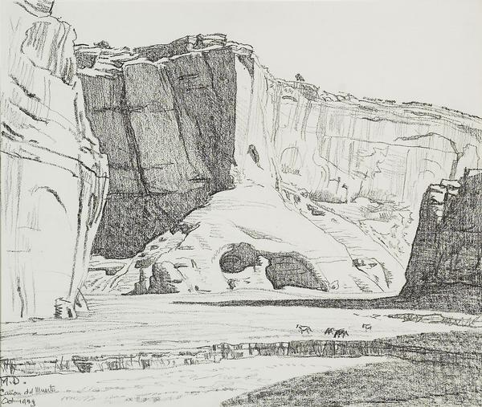](http://www.denverpost.com/portlet/article/html/imageDisplay.jsp?contentItemRelationshipId=5005000)

Maynard Dixon's "Canyon del Muerto" is a drawing he made during an excursion through the Southwest. (*Provided by Longmont Museum*)

[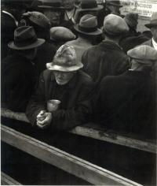](http://www.denverpost.com/portlet/article/html/imageDisplay.jsp?contentItemRelationshipId=5004998)

Dorothea Lange took this photo "White Angel Breadline" in San Francisco in 1933. The food distribution center was near her studio. (*Dorothea Lange, Provided by Longmont Museum*)

Of all the things that bring [a couple](http://en.wikipedia.org/wiki/Brangelina) together, love may be the least of them. It's the urgencies of shared concern that truly unite people, the connection of worry, and from that, the partnership of making things right.

And so there is little in the way of romance in two new art exhibits that connect the work of one husband to one wife, or maybe better to say, wife-to-husband, since the women here have the larger reputations.

At the [Longmont Museum Cultural Center](http://www.ci.longmont.co.us/museum/exhibits/index.htm), "American Visionaries" presents the historic photography of [Dorothea Lange](http://www.denverpost.com/art/ci_20146668), famous for capturing the rural down-and-outers of mid-20th century America, along with drawings from [Maynard Dixon](http://maynarddixon.org/), her one-time spouse and a revered painter, who concurrently captured scenes of hard-scrabble life in the Southwest.

And at the [Fulginiti Pavilion in Aurora](http://www.denverpost.com/theater/ci_21537599/small-boxfor-big-ideas-atfitzsimons): "Four Questions," a joint project exploring lingering questions from the Holocaust, created by feminist icon Judy Chicago of ["The Dinner Party"](http://www.brooklynmuseum.org/exhibitions/dinner_party/) renown, along with her husband, the respected photographer [Donald Woodman](http://donaldwoodman.com/).

Both shows pack a punch that is solemn and striking and nakedly straightforward. In Longmont, we get people forsaken, overlooked, yet dignified in their way. In Aurora, people destroyed, exploited and experimented upon in the name of a better world. The themes are tortuous all around, though the execution is something poetic and beautiful.

"Four Questions" is the more direct collaboration. At the center of the exhibit are four works and each poses an ethical question that could be tied to the barbaric events of The Holocaust — or to contemporary science and medicine. The artists then divide their pieces down the middle — 50-50 — presenting a scene from the Holocaust interspersed into a scene from our present-day world.

One question is, "Where should the line be drawn?" and for that the artists join one image of human experimentation at the [Dachau concentration camp](http://www.jewishvirtuallibrary.org/jsource/Holocaust/dachau.html) with a more current image of a monkey suffering at the hands of lab researchers.

Presentation is everything here. The works are folded accordion-style with each scene facing a different direction, so you see one image from the left, the other from the

[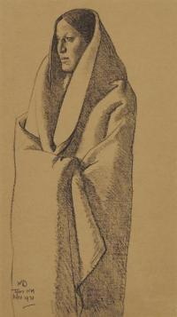](http://www.denverpost.com/portlet/article/html/imageDisplay.jsp?contentItemRelationshipId=5004997)

Maynard Dixon, onetime spouse of Dorothea Lange, with his "Earth Knower" from 1931. (*Provided by Longmont Museum*)

right. Looking directly, you get the horror of both scenes, but lose the specifics. It just looks blurry, confusing.

By blending two works — hers and his — Chicago and Woodman make a point: Difficult questions have multiple answers. There is more than one way to see the situation, and it changes over time, though every era calls upon us to do the right thing. Or fail tragically.

"Four Questions" is part of a larger work the couple has produced called "The Holocaust Project," but this bit of it stands well alone. The exhibit feels complete, thanks to the addition of individual framed studies the artists did for their part of the main pieces. The partnership of photographer and painter, each with their own way of seeing things, is clear and resounding.

**Lange and Dixon stayed solo**

Conversely, Lange and Dixon never intended their art to mingle, though they often traveled side-by-side. Still, there is a swell cohesion in the way they worked, and what they aimed for, and their output lives peacefully together on the walls in Longmont.

She, of course, is known for her scenes of Depression-era America, many commissioned by the New Deal's [Farm Security Administration](http://memory.loc.gov/ammem/fsahtml/fsainfo.html). One by one, Lange captured the struggling multitude, the unemployed migrant workers, landless tenant farmers, forlorn trailer camp residents and low-wage cotton pickers that defined the age in rural America.

Her photos have a startling duality. On one hand, the suffering of her subjects is clear. But they also display a sense of pride and purpose. In the midst of tragedy, they are stopped by Lange's camera (and no doubt, her charm) and afforded a moment of dignity.

Dixon is better known for his color-sharp oil paintings, but the pencil-on-paper drawings on display offer a glimpse into his process, and a nice connection to the black-and-white offerings from Lange.

He collected his own outsiders of that age — plains Indians, Mexican immigrants and ranch hands. His formal portraits here are the best: Navajo men posed like presidents, Mojave women rendered as if they were the [Madonna](http://www.britannica.com/EBchecked/topic/355920/Madonna) herself.

Dixon and Lange shared aspirations that were common, even trendy, for artists of their day. In an art world long defined by beautiful landscapes and faces of the rich, they conjured images of the underclass. This is what things really looked like outside of the big cities, and the movement broadened the scope of American art while helping its citizens see the whole of their country.

Lange and Dixon were a couple for 15 years, married in 1920, divorced in 1935, and their union was tumultuous at times. It is only the clever art of curation that reconciles them in retrospect for this exhibit.

While the show rings true, the whole act is a bit cute, and one wonders if they would be able to stand it themselves. Artists don't get much say in how their work is displayed once they're dead.

Chicago and Woodman, alive and kicking, nip that in the bud by joining forces on their own terms. It seems like a good strategy, really. Like all this work, it's less than romantic, but wise.

*Ray Mark Rinaldi: 303-954-1540, rrinaldi@denverpost.com or twitter.com/rayrinaldi*

**AMERICAN VISIONARIES: DOROTHEA LANGE AND MAYNARD DIXON.** An exhibit pairing Lange's photos with Dixon's drawings. Longmont Museum & Cultural Center, 400 Quail Road, Longmont. $5. **303-651-8374 or** [**longmontmuseum.org.**](http://www.longmontmuseum.org/)

**FOUR QUESTIONS.** A collaborative series of works from husband-and-wife artists Judy Chicago and Donald Woodman. Through May 30. Fulginiti Pavilion, on the Anschutz Medical Campus, 13080 E. 19th Ave., Aurora. Free. **303-724-3994 or** [**ucdenver.edu**](http://ucdenver.edu/)

http://analytics.apnewsregistry.com/analytics/v2/image.svc/36/RWS/www.denverpost.com/CAI/ci_22792717/E/prod/PC/Basic/AT/A[Copyright 2012 The Denver Post. All rights reserved.](http://www.denverpost.com/portlet/layout/html/privacypolicy/privacypolicy.jsp?siteId=36)

[**Follow Ray Mark Rinaldi on Twitter**](http://twitter.com/rayrinaldi).

[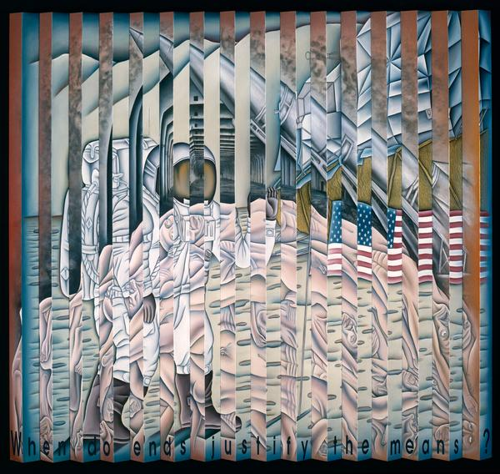](http://www.denverpost.com/portlet/article/html/imageDisplay.jsp?contentItemRelationshipId=5003339)

"When Do Ends Justify the Means?" is part of the "Four Questions" series by Judy Chicago and Donald Woodman. The display is at the Fulginiti Pavilion on the Anschutz Medical Campus, 13080 E. 19th

Read more: [Art by Judy Chicago and Dorothea Lange, and their husbands, highlighted in Colorado shows - The Denver Post](http://www.denverpost.com/news/ci_22792717#ixzz2NzzGYD6a) <http://www.denverpost.com/news/ci_22792717#ixzz2NzzGYD6a>   
Read The Denver Post's Terms of Use of its content: http://www.denverpost.com/termsofuse   
Follow us: [@Denverpost on Twitter](http://ec.tynt.com/b/rw?id=drJey4bd8r3PGFab7jrHtB&u=Denverpost) | [Denverpost on Facebook](http://ec.tynt.com/b/rf?id=drJey4bd8r3PGFab7jrHtB&u=Denverpost)